Experiment: Implementation of Naïve Bayes Algorithm in Python
Aim
To implement the Naïve Bayes algorithm in Python and evaluate its performance using a confusion matrix and accuracy.
Theory
The Naïve Bayes algorithm is a supervised machine learning classification algorithm based on Bayes' Theorem. It assumes that all features are independent of each other.
It is widely used for classification problems such as spam detection, medical diagnosis, and text classification.
Procedure
- Import the required Python libraries.
- Load the Iris dataset.
- Split the dataset into training and testing sets.
- Create the Naïve Bayes classifier.
- Train the classifier using the training dataset.
- Predict the class labels for the test dataset.
- Generate the confusion matrix.
- Calculate the accuracy of the model.
- Display the confusion matrix, accuracy, and predicted values.
Python Program
Python
Run
from sklearn.datasets import load_iris
from sklearn.model_selection import train_test_split
from sklearn.naive_bayes import GaussianNB
from sklearn.metrics import confusion_matrix, accuracy_score
# Load Iris Dataset
iris = load_iris()
X = iris.data
y = iris.target
# Split dataset
X_train, X_test, y_train, y_test = train_test_split(
X, y, test_size=0.3, random_state=1
)
# Create Naive Bayes classifier
model = GaussianNB()
# Train the model
model.fit(X_train, y_train
# Predict
y_pred = model.predict(X_test)
# Confusion Matrix
cm = confusion_matrix(y_test, y_pred)
# Accuracy
accuracy = accuracy_score(y_test, y_pred)
# Display Results
print("Confusion Matrix:")
print(cm)
print("\nActual Values:")
print(y_test)
print("\nPredicted Values:")
print(y_pred)
print("\nAccuracy:", accuracy)
Output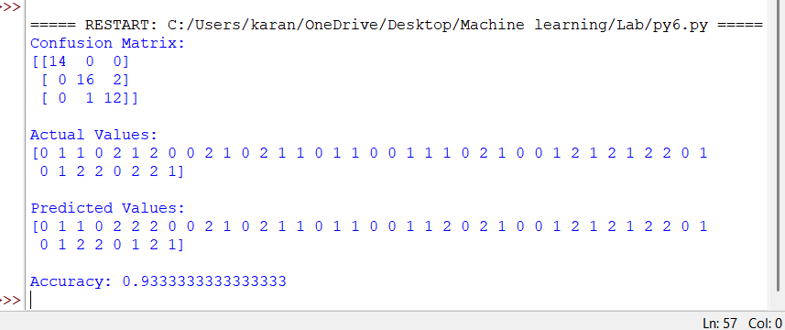
Result
The Naïve Bayes algorithm was successfully implemented in Python. The classifier was trained and tested using the Iris dataset. The model performance was evaluated using the confusion matrix and accuracy, and it achieved satisfactory classification results.

